Use by the community

- At special times of need, people come into St Alkmund’s, sensing that it is a place where reflection and prayer can take place and comfort be found.
- The civic Remembrance Service is held in St Alkmund’s each November, with hundreds of people present.
- St Alkmund’s hosts concerts, and organises special events such as the Crib Festival.
- The Crib Services on Christmas Eve are attended by more than 900 people each year.
- Most funeral services and baptisms in Whitchurch take place in St Alkmund’s, as do many weddings. Generations of Whitchurch families have had these services and therefore have strong links with St Alkmund’s.
- These links are also present through the Junior and Nursery / Infant Schools which use the church regularly.

Visitors
- The number of visitors is considerable: 287 people signed the Visitors’ Book between April and September in 2012 and only a fraction of visitors do so.
- These people also use the shops, pubs and cafés in the town and so are important for our economy.

For reasons such as these, we hope that you will consider becoming a Friend and helping to secure St Alkmund’s church building, grounds and parish hall for the future.

To enrol as a Friend for a minimum annual outlay of £15 for an individual, £25 for a family or £50 for corporate membership, please complete the form inside and return as detailed.
For more information, please contact
Judy Routledge on 01948 662441

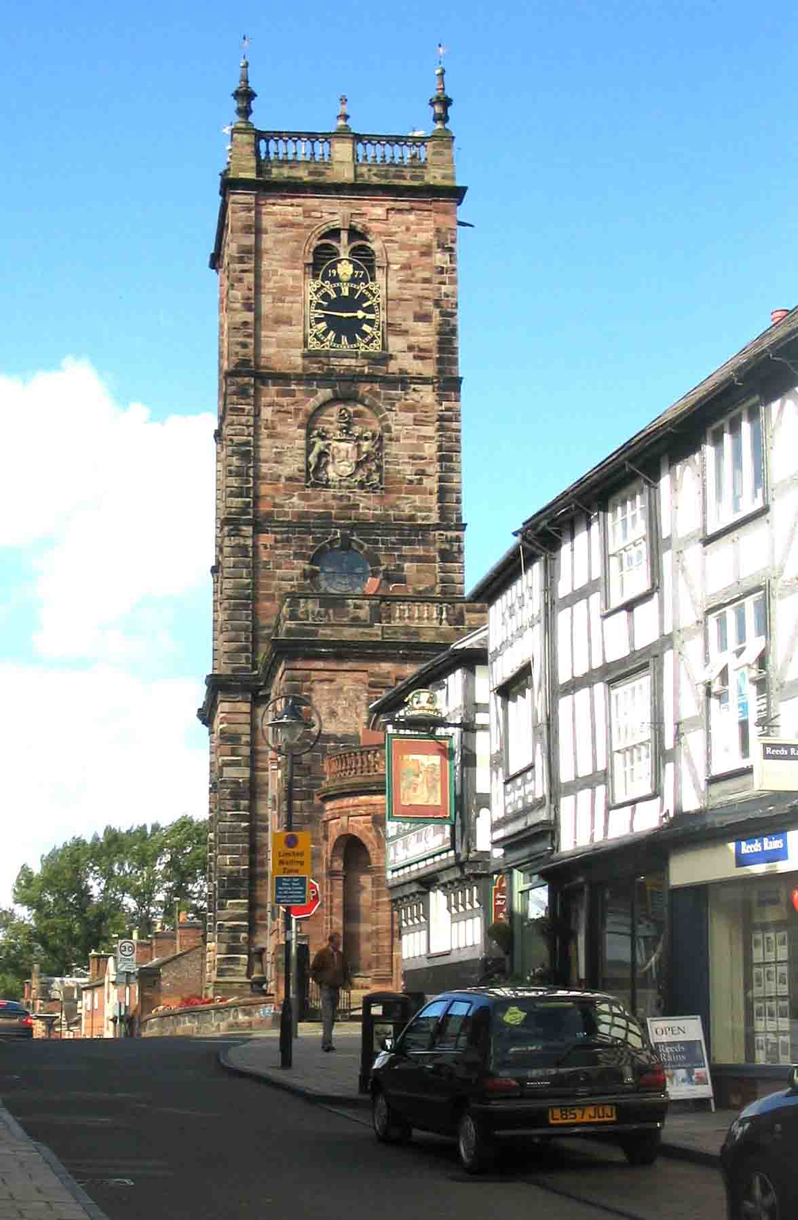
THE FRIENDS
OF
ST ALKMUND’S

WHITCHURCH

Registered charity number 1151968

Not just for Sunday services ……

The Parochial Church Council of St Alkmund’s aims to ensure that all residents and visitors can have easy access to the church building and feel welcome to come in for quiet prayer, services and other events. The church is open between 10.00am and 5.00pm every day.

Why become a Friend?

Many people feel that St Alkmund’s, with its fine church building, grounds and parish hall, is important for the whole community and should not fall into disrepair. Several projects are now being planned to improve the buildings. Please join us in safeguarding the future of St Alkmund’s.

What work needs to be done on the church buildings?

1. Permanent stone ramp to the porch: £25-30,000

In order to make the church fully accessible, the PCC proposes to build a permanent stone ramp along the south wall, enabling those who find steps difficult to access the church by the main door

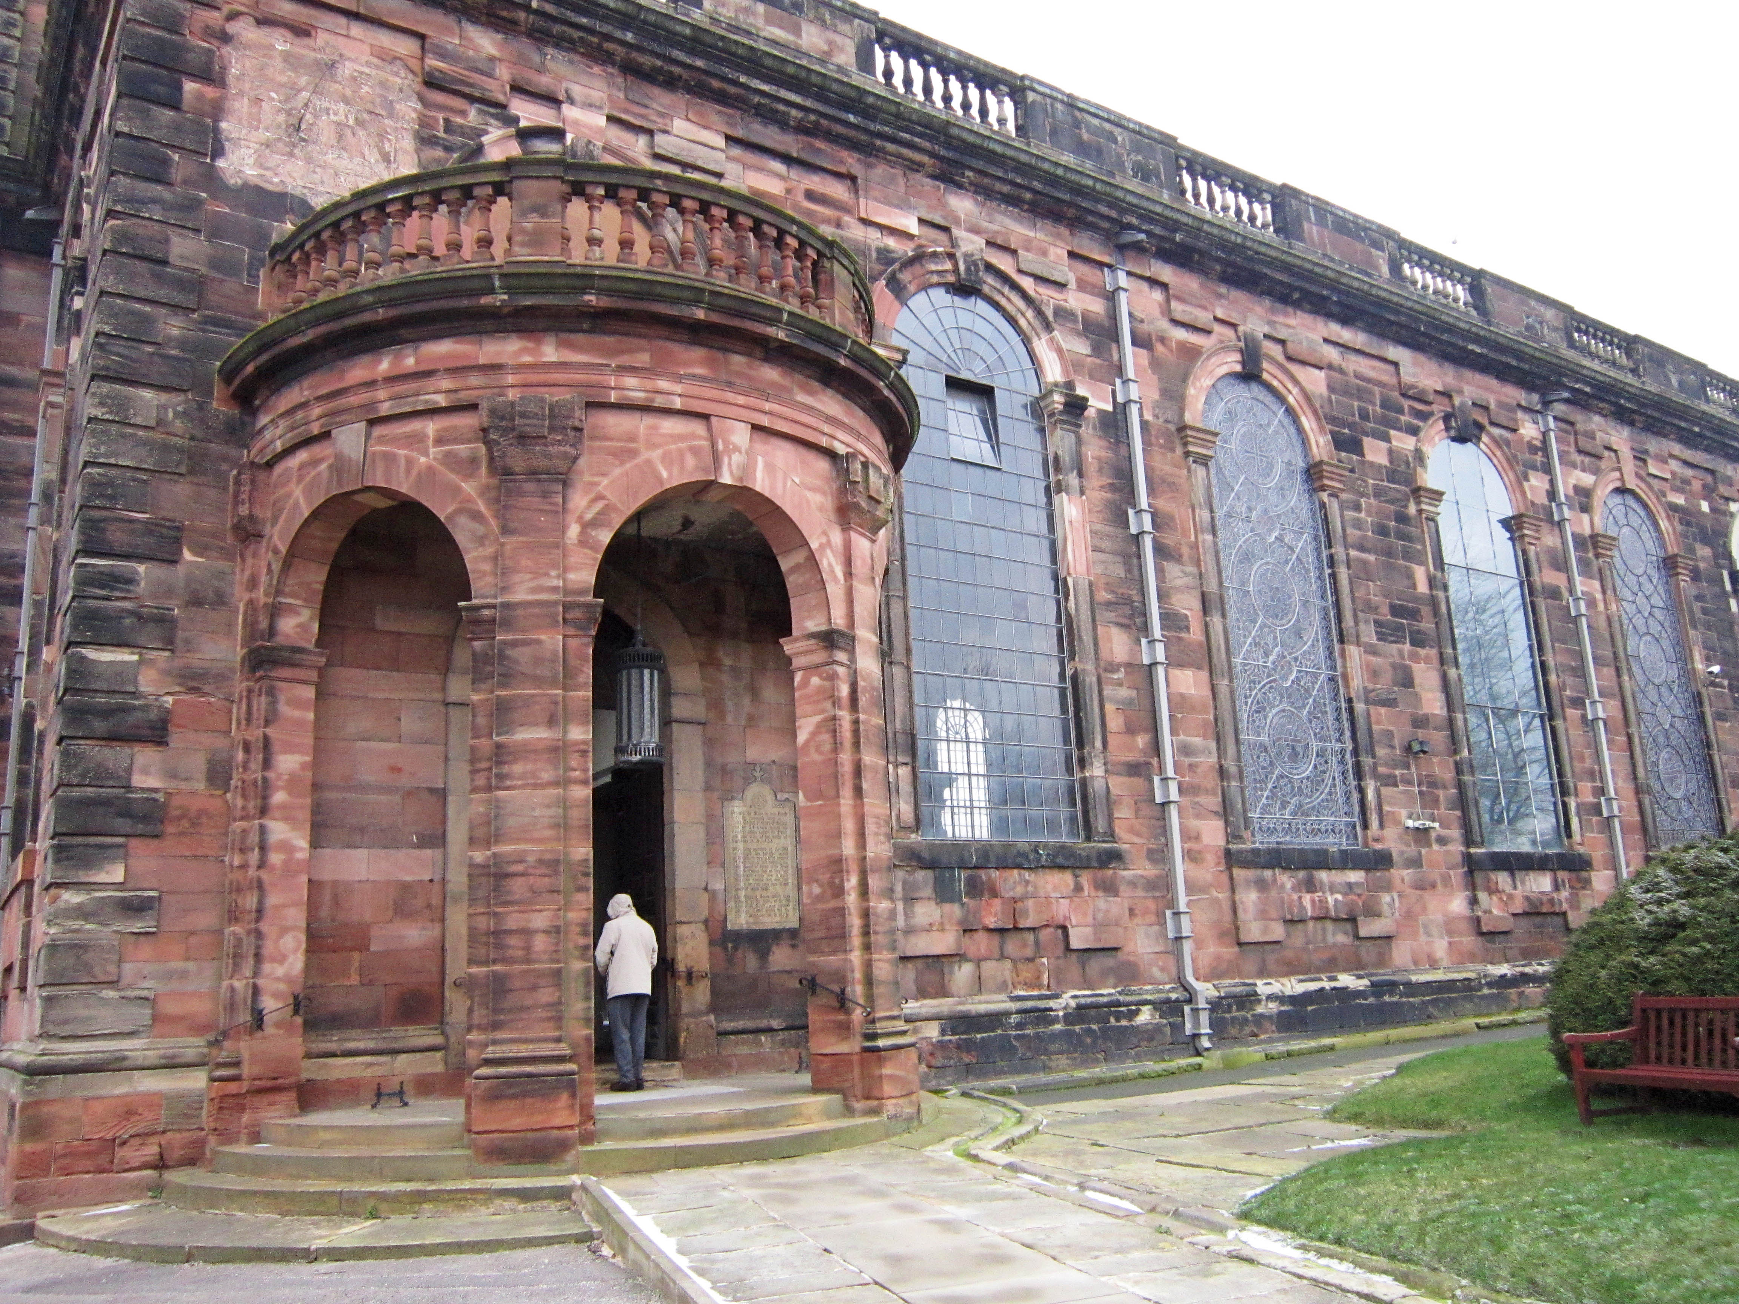

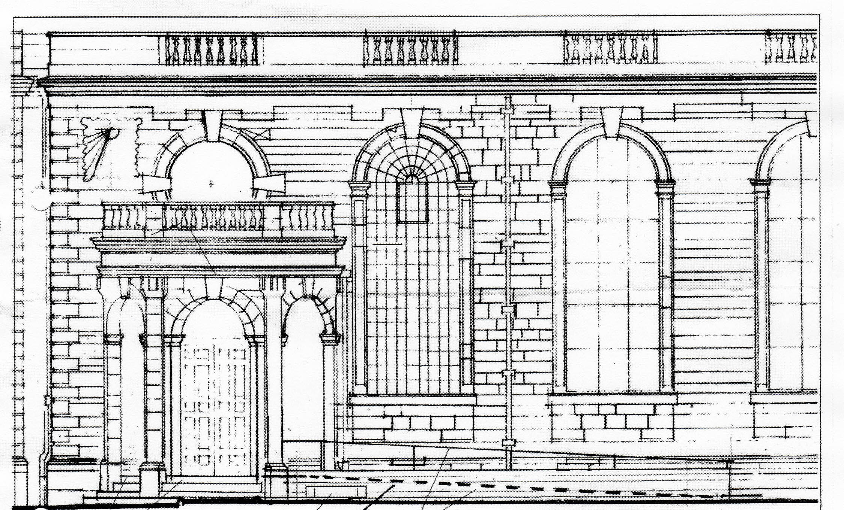

- - - Floor of the ramp behind stone plinth wall and hand rail

2. External stonework and other repairs: £350,000

External sandstone and stained glass windows at the east end, south porch roof, north porch steps, stone drainage channels and rainwater pipe outlets are all in need of repair
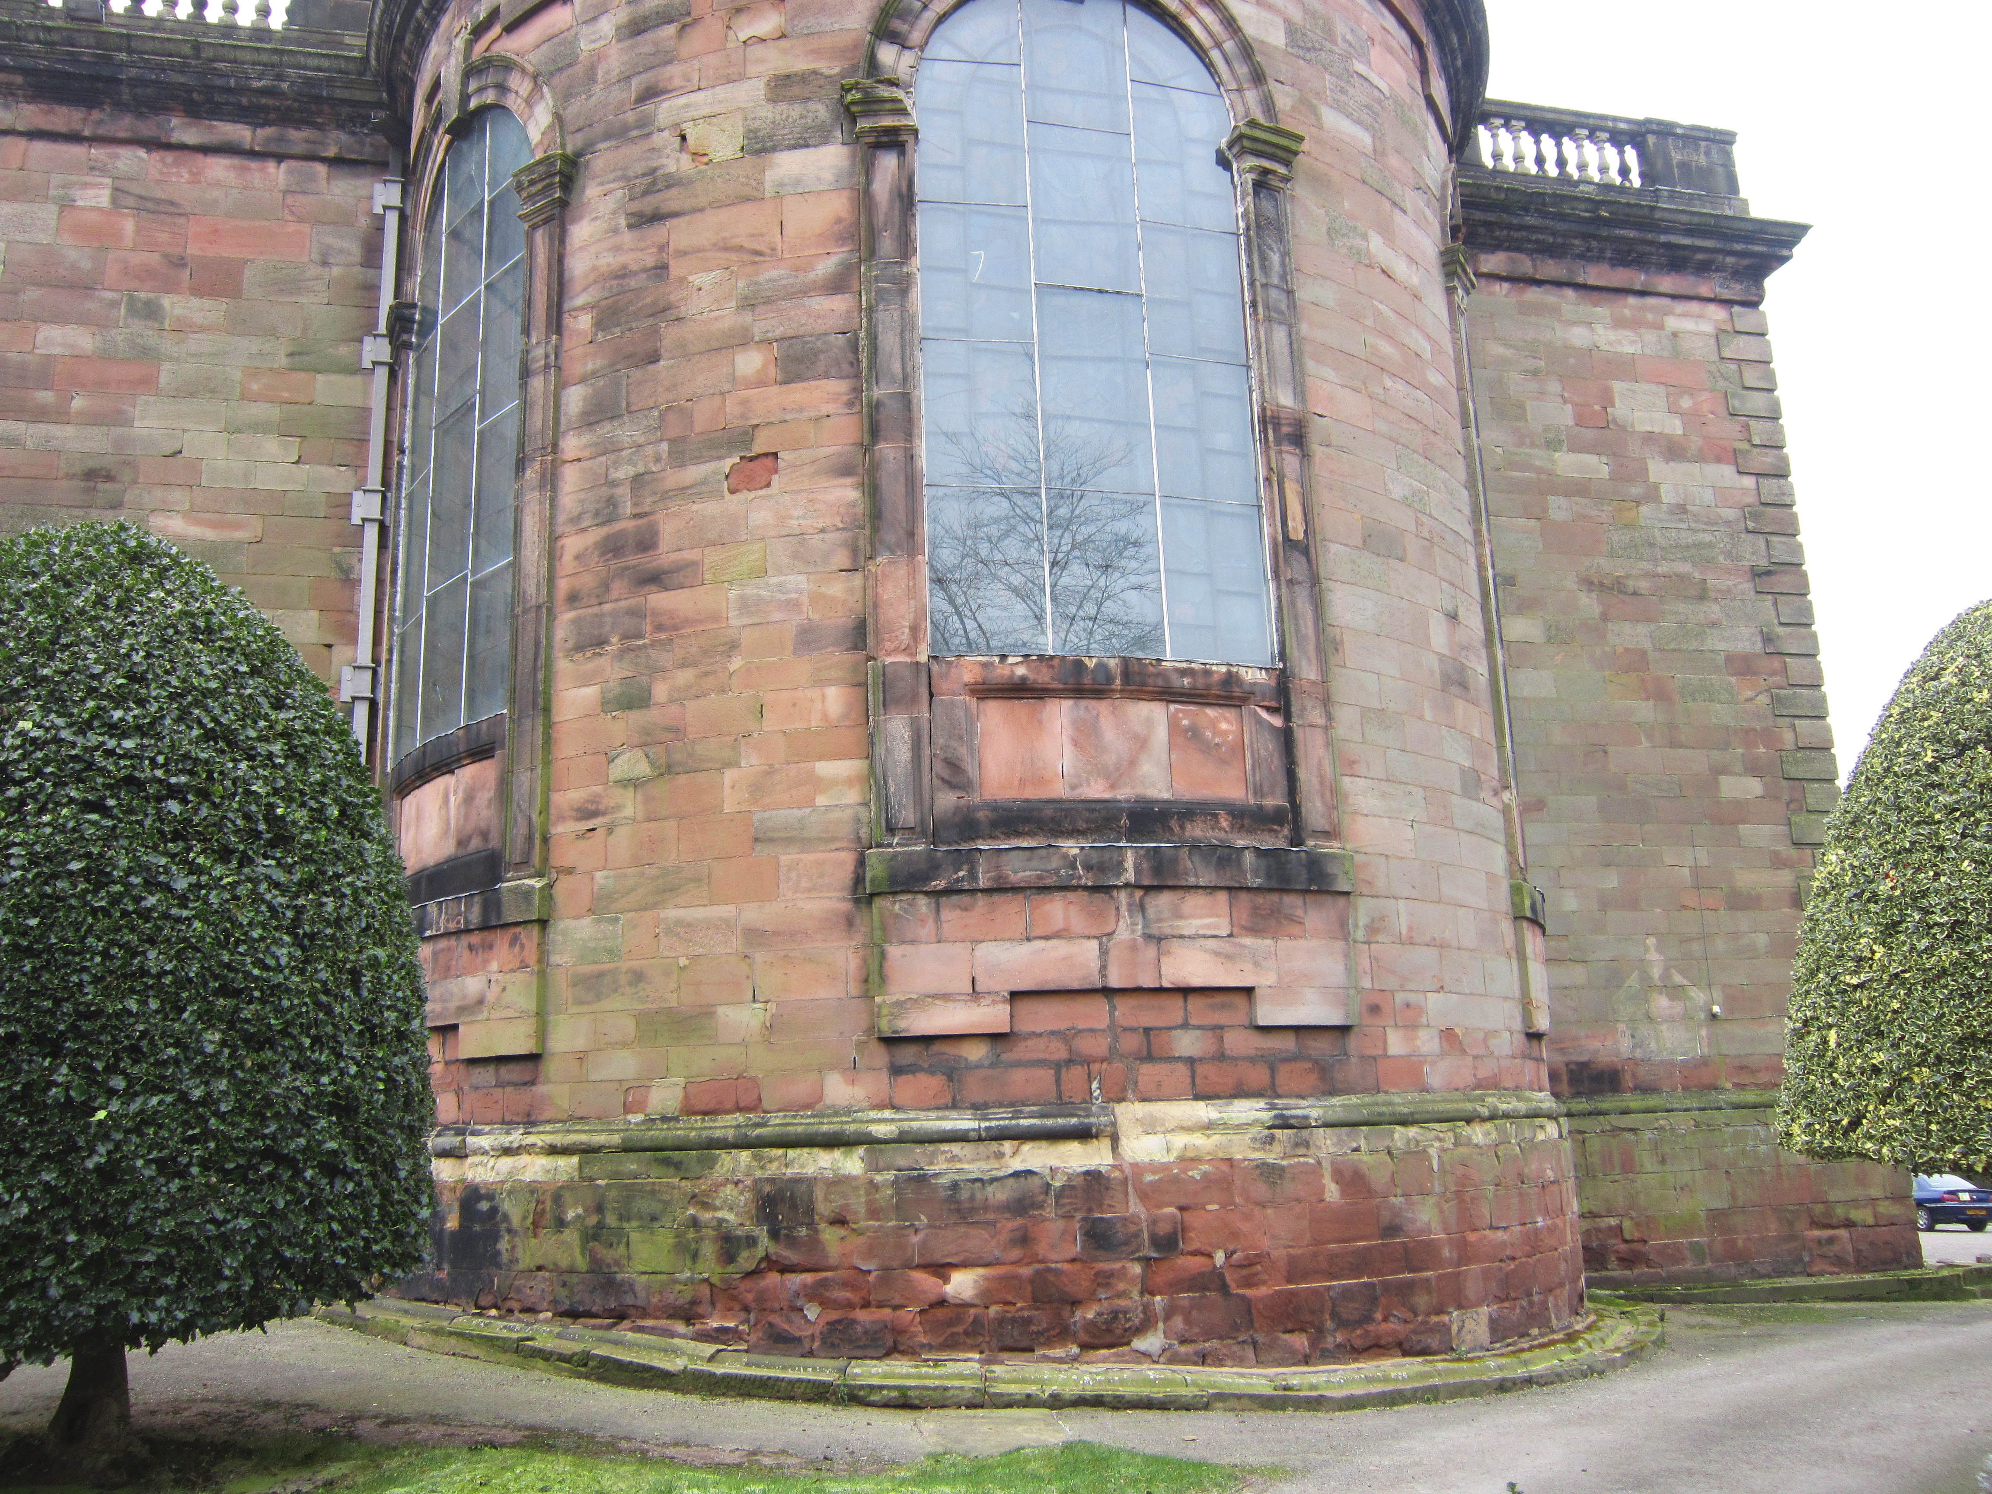

3. Renovation of Bargates Hall: £25-30,000

Renovation has started with damp proofing and modernisation of the interior to present standards (see below)

